Appendix for “Production, transportation and food prices in Nepal”
Table A1: Local markets and associated regional and border markets
Local market | Regional market | Border market
Bardiya | Kailali | Paliya
Bhojpur | Morang | Jogbani
Dailekh | Banke | Rupedihya
Dhading | Chitwan | Raxaul
Dhankuta | Morang | Jogbani
Dhanusha | Siraha | Sonabarsha
Dolakha | Chitwan | Raxaul
Doti | Kailali | Paliya
Gorkha | Chitwan | Raxaul
Illam | Jhapa | Naxalbadi
Jajarkot | Banke | Rupedihya
Jumla | Banke | Rupedihya
Kanchanpur | Kailali | Paliya
Kaski | Chitwan | Raxaul
Khotang | Siraha | Sonabarsha
Mahottari | Siraha | Sonabarsha
Nuwakot | Chitwan | Raxaul
Palpa | Rupandehi | Nautanawa
Ramechhap | Chitwan | Raxaul
Rolpa | Rupandehi | Nautanawa
Rukum | Rupandehi | Nautanawa
Sarlahi | Parsa | Raxaul
Sindhupalchowk | Chitwan | Raxaul
Solukhambu | Siraha | Sonabarsha
Surkhet | Banke | Rupedihya
Tanahun | Chitwan | Raxaul
Taplejung | Jhapa | Naxalbadi
Udaypur | Siraha | Sonabarsha
Table A2: Correlation matrix for retail food prices in Nepal (2002-2010)
 | Coarse Rice | Medium Rice | Fine Rice | Wheat Flour | Red Potato | White Potato
Coarse  Rice | 1.00
Medium  Rice | 0.93* | 1.00
Fine  Rice | 0.75* | 0.84* | 1.00
Wheat  Flour | 0.86* | 0.82* | 0.65* | 1.00
Red  Potato | 0.44* | 0.47* | 0.45* | 0.37* | 1.00
White  Potato | 0.44* | 0.49* | 0.44* | 0.39* | 0.88* | 1.00
Note: *indicates the correlation is significantly different from zero at a 1% test level. Correlations computed using monthly retail prices from 20 districts (Bhojpur, Dhankuta, Doti, Illam, Jumla, Kaski, Kathmandu, Nuwakot, Palpa, Ramechhap, Rolpa, Banke, Chitwan, Dhanusa, Jhapa, Kailali, Morang, Parsa, Rupandehi and Surkhet).

Table A3: Alternative AGARCH model specifications for rice
 | Model A | Model B | Model C | Model D | Model E
Mean equation
Time trend  (monthly unit-step) | 0.00017**  (0.00009) |  |  | 0.00007  (0.00012) | 0.00014  (0.00009)
Local price  (t-1) | 0.91284***  (0.00738) |  |  | 0.90215***  (0.00824) | 0.90835***  (0.00764)
Regional market price (current) | 0.05453***  (0.01627) |  |  | 0.05924***  (0.01384) | 0.061657***  (0.016277)
Regional market price  (t-1) | -0.06346***  (0.01575) |  |  | -0.05147***  (0.01340) | -0.062511***  (0.01582)
Central market price  (current) | 0.01649  (0.01642) |  |  | 0.02140  (0.01493) | 0.020789  (0.01667)
Central market price  (t-1) | 0.01266  (0.01550) |  |  | 0.00415  (0.01463) | 0.015514  (0.015514)
Border market price  (current) | -0.01655  (0.01897) |  |  | -0.01516  (0.01901) | -0.016034  (0.018927)
Border market price  (t-1) | 0.00407  (0.01620) |  |  | -0.00296  (0.01661) | 0.013838  (0.01611)
Road density  (weighted km/km²) |  | -0.00057***  (0.00007) |  | -0.00012***  (0.00005)
Bridge density  (#/km²) |  | -0.01820***  (0.00338) |  | -0.00329  (0.00213)
Mountain×Road density (interaction) |  | -0.00878***  (0.00031) |  | -0.00063***  (0.00022)
Mountain×Bridge density (interaction) |  | 0.12605  (0.16179) |  | 0.02697  (0.17750)
Terai×Road density (interaction) |  | 0.00129***  (0.00015) |  | 0.00008  (0.00012)
Terai×Bridge density (interaction) |  | 0.02480***  (0.00619) |  | 0.00825*  (0.00448)
Monthly fuel price (Rs/liter) |  | 0.35195***  (0.02092) |  | 0.03855  (0.02978)
District population  (#/km2) |  |  | 0.000254***  (0.00002) |  | 0.00001  (0.00002)
Rice production  (1000 MT)a |  |  | -0.09174***  (0.00275) |  | -0.00558**  (0.00233)
Monthly exchange rate  (Nepal Rs/USD) |  |  | -0.22467***  (0.04446) |  | -0.094145**  (0.04124)
Terai  (0/1) | -0.01582***  (0.00415) | -0.27331***  (0.01275) | -0.05932***  (0.00718) | -0.03188***  (0.01194) | -0.01545***  (0.00608)
Mountain  (0/1) | 0.01888***  (0.00543) | 0.48962***  (0.01263) | 0.156252***  (0.005493) | 0.02975***  (0.00825) | 0.007446  (0.00507)
Constant | 0.23915**  (0.09445) | 1.80918***  (0.07560) | 4.21828***  (0.19178) | 0.13094  (0.12364) | 0.6062***  (0.17992)

Table A3 concluded
 | Model A | Model B | Model C | Model D | Model E
Variance Equation
Time trend  (monthly unit-step) | 0.00341***  (0.00115) |  |  | 0.00690***  (0.00115) | 0.0036***  (0.00103)
Regional market price  (t-1) | -3.84697***  (0.36252) |  |  | -2.77362***  (0.29936) | -3.64384***  (0.30855)
Central market price  (t-1) | 1.85903***  (0.21420) |  |  | 1.24980***  (0.17169) | 1.63597***  (0.19038
Border market price  (t-1) | 0.83035**  (0.35120) |  |  | 1.01556***  (0.28095) | 0.77870***  (0.31663)
Road density  (weighted km/km²) |  | -0.00456***  (0.00184) |  | -0.00843***  (0.00088)
Bridge density  (#/km²) |  | -0.08922  (0.10310) |  | 0.05533  (0.04706)
Monthly fuel price (Rs/liter) |  | -0.86214***  (0.25501) |  | -1.31345***  (0.20149)
District population  (#/km²) |  |  | 0.00019  (0.00033) |  | -.0002444  (0.00018)
Rice production  (1000 MT)ª |  |  | -0.240245***  (0.044579) |  | -0.142013***  (0.021764)
Monthly exchange rate  (Nepal Rs/USD) |  |  | -1.54128**  (0.72838) |  | -0.664538  (0.43482)
Terai  (0/1) | 0.01658  (0.06593) | 0.47113**  (0.20071) |  | 0.40995***  (0.09915)
Mountain  (0/1) | 0.64908***  (0.05499) | 1.24528***  (0.11726) |  | 0.50198***  (0.05395)
Constant | -4.18035***  (1.01107) | -2.73802***  (0.91524) | 1.49915  (3.13928) | -0.17108  (0.93167) | -1.22329  (2.14065)
L.ARCH | 0.08259***  (0.00762) | 0.55443***  (0.04973) | 0.588687***  (0.04563) | 0.12895***  (0.01285) | 0.098758***  (0.00998)
L.GARCH | 0.77491***  (0.01488) | 0.34761***  (0.02861) | 0.30975***  (0.02099) | 0.60075***  (0.02661) | 0.703468***  (0.020674)
L.AGARCH | 0.01297***  (0.00151) | 0.00963***  (0.00350) | 0.012624***  (0.003858) | 0.01863***  (0.00385) | 0.0137538***  (0.00177))
Districts | 28 | 28 | 28 | 28 | 28
Observations | 2,996 | 2,996 | 2,996 | 2,996 | 2,996
Note: ªInstrumented value; standard errors appear in parentheses; ***indicates p<0.01, **p<0.05, *p<0.1. Agricultural prices, fuel prices, exchange rate, and harvest variables have been converted to natural logarithm form. Agroecological zone (k=3), year, and monthly fixed effects are included in the mean equations.

Table A4: Alternative TGARCH model specifications for wheat
 | Model A | Model B | Model C | Model D | Model E
Mean equation
Time trend  (monthly unit-step) | 0.00022**  (0.00009) |  |  | 0.00027**  (0.00013) | 0.00032***  (0.00010)
Local price  (t-1) | 0.93246***  (0.00582) |  |  | 0.88415***  (0.00794) | 0.91755***  (0.00647)
Regional market price  (current) | 0.00654  (0.01598) |  |  | 0.02243  (0.01856) | 0.017536  (0.01806)
Regional market price  (t-1) | -0.01650  (0.01724) |  |  | -0.01695  (0.01865) | -0.01635  (0.0181)
Central market price  (current) | 0.01153  (0.02638) |  |  | 0.01850  (0.02708) | 0.006436  (0.02671)
Central market price  (t-1) | -0.09677***  (0.01768) |  |  | -0.10417***  (0.01972) | -0.10678***  (0.01771)
Border market price  (current) | 0.10230***  (0.01951) |  |  | 0.08100***  (0.02091) | 0.109611***  (0.020659)
Border market price  (t-1) | -0.09375***  (0.01747) |  |  | -0.09913***  (0.01861) | -0.09683***  (0.018997)
Road density  (weighted km/km²) |  | -0.00123***  (0.00005) |  | -0.00022***  (0.00006)
Bridge density  (#/km²) |  | -0.01713***  (0.00209) |  | -0.00027  (0.00230)
Mountain×Road density  (interaction) |  | -0.00748***  (0.00033) |  | -0.00089***  (0.00023)
Mountain×Bridge density  (interaction) |  | 0.44380**  (0.21664) |  | -0.14652  (0.14479)
Terai×Road density  (interaction) |  | 0.00179***  (0.00011) |  | 0.00041***  (0.00013)
Terai×Bridge density  (interaction) |  | 0.03804***  (0.00407) |  | 0.00160  (0.00479)
Monthly fuel price  (Rs/liter) |  | 0.06734**  (0.03031) |  | 0.02154  (0.03357)
District population  (#/km²) |  |  | 0.00005**  (0.00001) |  | 0.00001  (0.00002)
Wheat production  (1000 MT)ª |  |  | -0.06457***  (0.00266) |  | -0.0078***  (0.0021)
Monthly exchange rate  (Nepal Rs/USD) |  |  | 0.026439  (0.04294) |  | -0.00764  (0.0021)
Terai  (0/1) | -0.01140***  (0.00428) | -0.37995***  (0.00701) | -0.11094***  (0.00578) | -0.0552***  (0.01192) | -0.00793  (0.04117)
Mountain  (0/1) | 0.02533***  (0.00513) | 0.35535***  (0.01394) | 0.03633***  (0.00526) | 0.05713***  (0.00839) | 0.018955***  (0.00469)
Constant | 0.44800***  (0.09839) | 2.97697***  (0.11198) | 3.23642***  (0.184077) | 0.55799***  (0.14060) | 0.54242**  (0.20377)

Table A4 concluded
 | Model A | Model B | Model C | Model D | Model E
Variance Equation
Time trend  (monthly unit-step) | -0.01313***  (0.00170) |  |  | -0.00555  (0.00181) | -0.01122***  (0.00163)
Regional market price  (t-1) | -1.48901***  (0.62285) |  |  | -1.21252**  (0.58920) | -1.16133***  (0.55278)
Central market price  (t-1) | 4.52873***  (0.58636) |  |  | 3.40844***  (0.57540) | 3.89516***  (0.52528)
Border market price  (t-1) | 2.37087***  (0.42424) |  |  | 2.41993***  (0.37623) | 2.75003***  (0.39492)
Road density  (weighted km/km²) |  | -0.00567***  (0.002093) |  | -0.00656***  (0.00127)
Bridge density  (#/km²) |  | -0.15042  (0.116314) |  | -0.05332  (0.05051)
Monthly fuel price  (Rs/liter) |  | -2.22213  (0.450307) |  | -1.21261***  (0.34206)
District population  (#/km²) |  |  | -0.00038  (0.00055) |  | -0.001524***  (0.00032)
Monthly exchange rate  (Nepal Rs/USD) |  |  | 6.55628***  (1.17729) |  | 2.87688***  (0.71081)
Wheat production  (1000 MT)ª |  |  | -0.16466***  (0.02225) |  | -0.16078***  (0.03696)
Terai  (0/1) | 0.06299  (0.08731) | 0.366345  (0.23697) |  | 0.29120***  (0.10435)
Mountain  (0/1) | 0.85700***  (0.06660) | 1.357151***  (0.100142) |  | 0.59394***  (0.08123)
Constant | -22.6348***  (1.51114) | 1.65202  (1.63287) | -34.0982***  (5.15067) | -15.412***  (1.32648) | -34.5244***  (3.6116)
L.ARCH | 0.13772***  (0.01362) | 0.593293***  (0.051363) | 0.567334***  (0.041446) | 0.16126***  (0.01905) | 0.15913***  (0.01731)
L.GARCH | 0.71801***  (0.00827) | 0.488217***  (0.015467) | 0.470985***  (0.016332) | 0.68834***  (0.01215) | 0.70261***  (0.00998)
L.TARCH | 0.27455***  (0.02299) | -0.04451  (0.052044) | 0.01812  (0.0474) | 0.21925***  (0.02861) | 0.24469***  (0.02559)
Number of districts | 28 | 28 | 28 | 28 | 28
Observations | 2,996 | 2,996 | 2,996 | 2,996 | 2,996
ªInstrumented value; standard errors appear in parentheses; ***indicates p<0.01, **p<0.05, *p<0.1. Agricultural prices, fuel prices, exchange rate, and harvest variables have been converted to natural logarithm form. Agroecological zone (k=3), year, and monthly fixed effects are included in the mean equations.

Figure A1: Road length (km) in Jumla, Kaski and Mahottari districts (2002-2010)

Figure A2: Nominal retail price of diesel fuel in Kathmandu, Nepal (1985-2015)

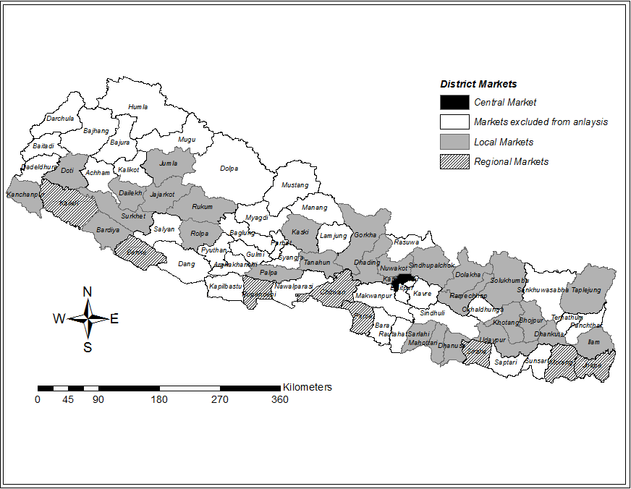Figure A3: Map of Nepal showing districts covered by the analysis

Figure A4: Monthly coarse rice prices in Nepal (real, 2002-2010)

Figure A5: Monthly wheat flour prices in Nepal (real, 2002-2010)

Figure A6: Total rice and wheat production and yield in Nepal (1985-2011)

